Threat intelligence for soc

SSh access to the machine

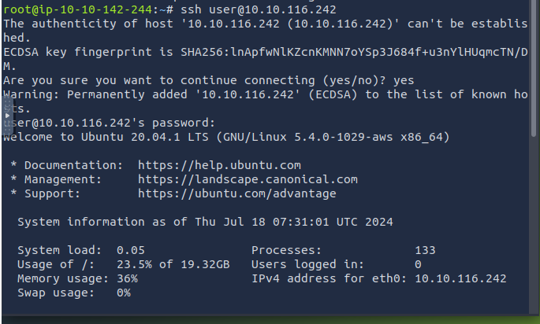

Kibana instance through the ssh logged in machine

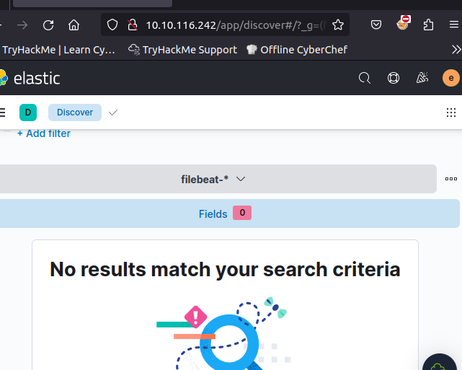

Uncoder List of iocs translated to elastic stack query

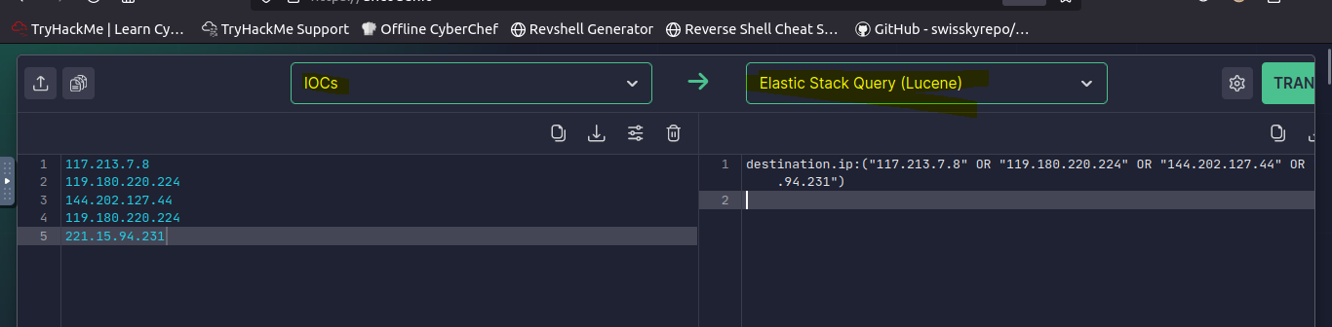

The number of hits in the timeframe

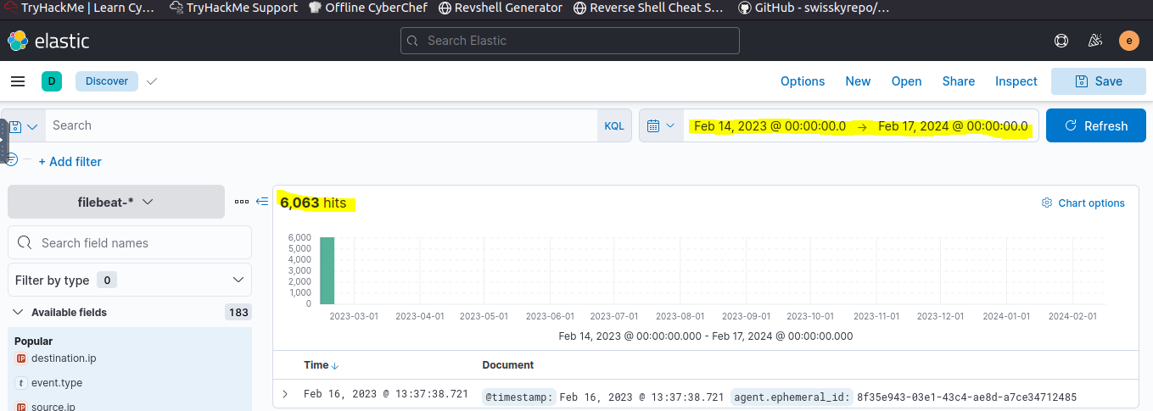

Different ioc list of 15 entries – 11 ip addresses

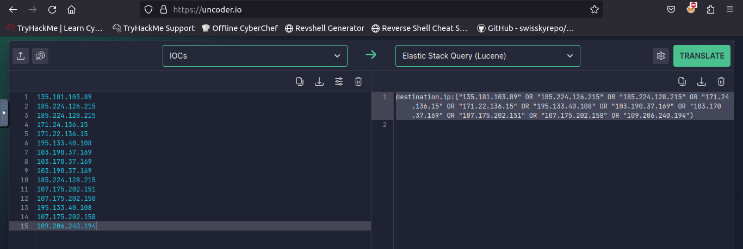

Based on the ioc list : the number of hits

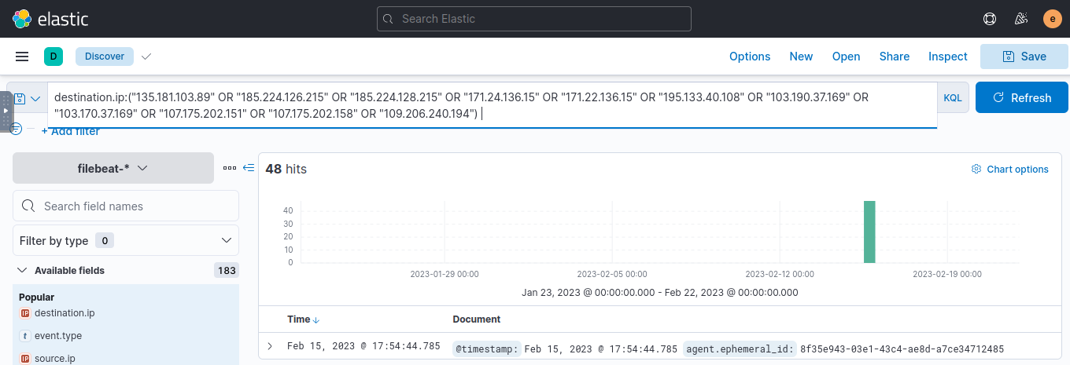

DNS PREVENTION

Dns question for the particular domain name

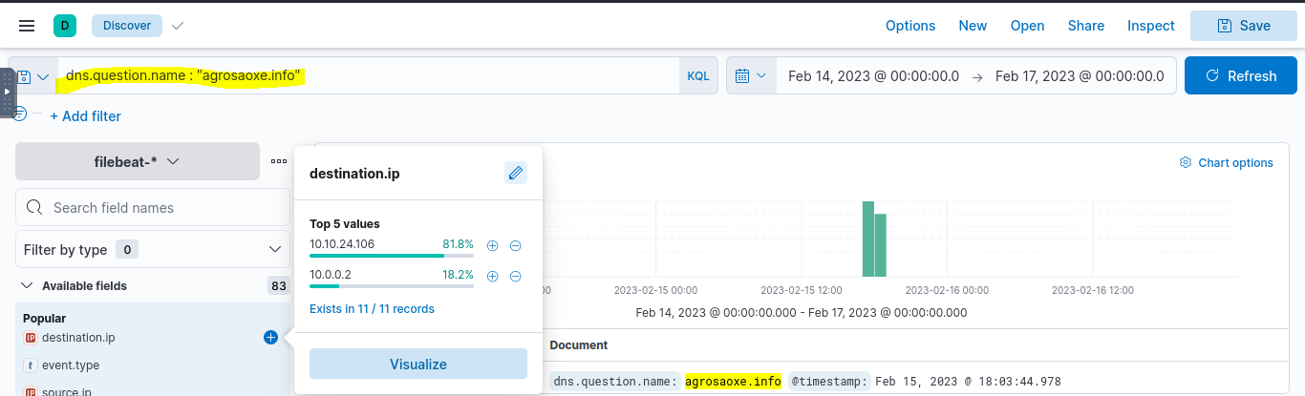

Dns resolved ip

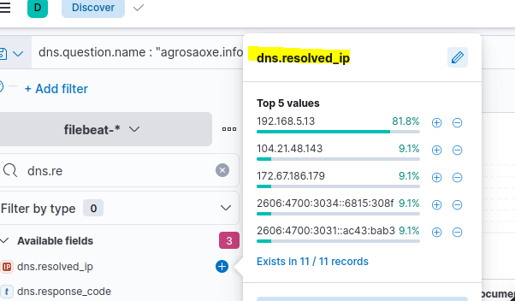

192.168.5.13 – the sinkhole ip

Next two are resolved ip

Threat detection

Sigma rule to elastalert

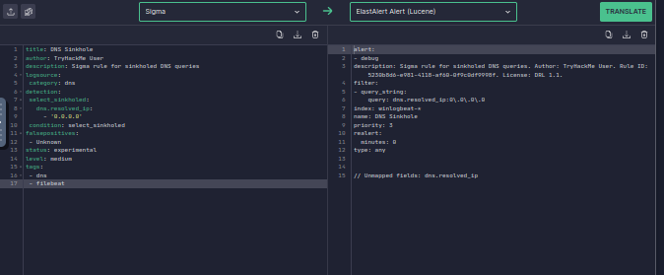

Ssh to the machine and the files

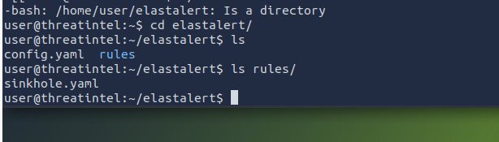

The translated elasalert to sinkhole.yaml

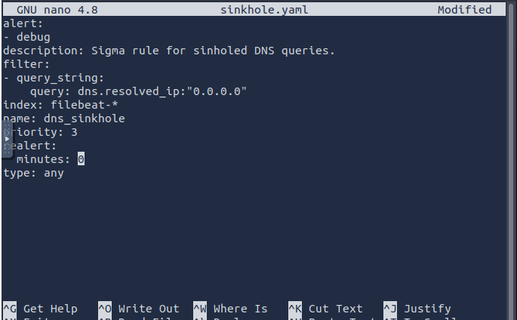

Running the command to start

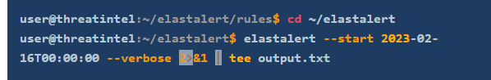

Running

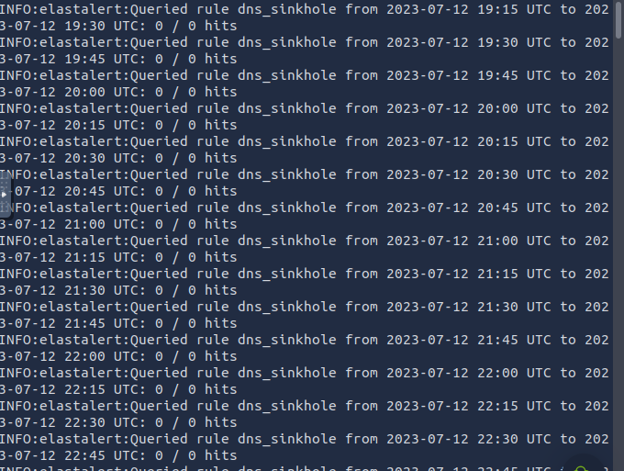

Alerts created by the rule

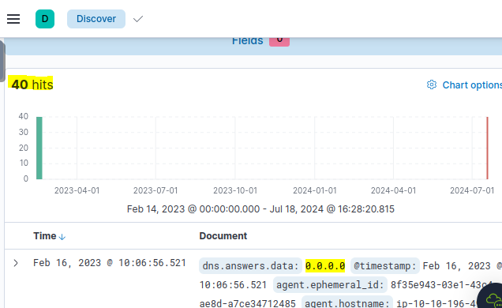

Unique sinkholes

